

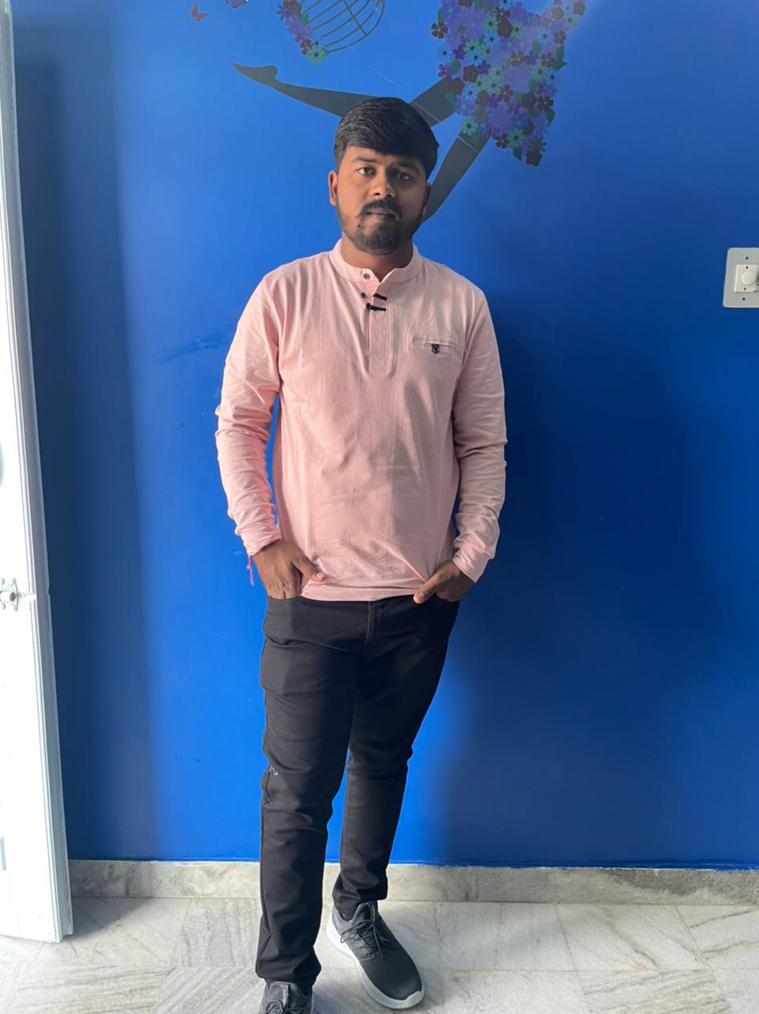**BIO DATA**

**PERSONAL DETAILS**

Name : Rishabh Jain

Date of birth : 22th – July – 2001

Time of Birth : 11:35 P.M.

Place of birth : Jodhpur

Color complexion : Fair

Height : 5 feet 7 inches

Qualification : B.Com.

Occupation : Business Man

Hobbies : Travelling

Sakha : Self- Bumb

Maternal’s - Kothari

Father’s maternal – Chopra

Mother’s maternal – Lalwani

**FAMILY DETAILS**

Father : Mr. Ajit Kumar Bumb

Mother : Mrs. Babita Devi Bumb

Younger Brother : Naman Bumb

Younger sister : Mayuri bumb

**PATERNAL FAMILY**

Grand Father : Late Bastimal Sa Bumb

Grand Mother : Smt. Madan Devi bumb

Elder Father : Mr. Suraj Kumar Bumb



Elder Mother : Mrs. Alpa Devi Bumb

Uncle : Mr. Manmohan Kumar Bumb

Aunt : Mrs. Mamta Devi Bumb

Uncle : Mr. Shripal Kumar Bumb

Aunt : Mrs. Suman Devi Bumb

Fufosa : Mr. Trilok Sa Singhivi

Bhua : Mrs. Lajwanti Ji Singhivi

**Naniyal family**

Nana : Late Parasmal Sa Kothari

Nani : Smt. Shakuntala Devi Kothari

Mama : Mr. Rajesh Sa Kothari

Mami : Mrs. Seema Devi Kothari

Masosa & Masi : Mr. Surendra Kumar Loonker

Mrs. Kusum Devi Loonker

: Mr. Manish Kumar Mutha

Mrs. Nisha Devi Mutha

: Mr. Pankaj Kumar Kawad

Mrs. Priyanka Devi Kawad

**CONTACT DETAILS**

Contact Number : 9414813723, 6377445151

Address : Chhaganiyo ka Mohalla, Merta city, Nagaur, (Rajasthan)